Task 1: Build the game

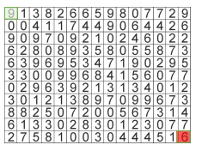• Generate random environments

• Program algorithmic strategies:

• One baseline

• Ant-based colonies

• Dijkstra's algorithm

• Compare how well they are doing:

• Computation time

• How well does it scale with the size of the environment

Task 2: Classification on MNIST

• Instead of perceiving a matrix of numbers, the agent

perceives a matrix of images

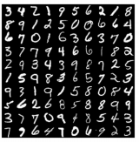• It must now translate these images into numbers

• You will build a neural network step-by-step to classify

MNIST images into numbers

• How does the perception accuracy influence the agent's

performance?

Task 3: Compare your results with Pytorch

• Reproduce the network you built by hand in Task 2:

• Use Pytorch

* If possible, use a GPU

• Compare the results with PyTorch:

• Speed?

• Accuracy?

• Build a CNN in PyTorch to classify the digits.

Task 4: Where the fun begins (bonus)

• Pick a topic!

• Solving any maze with RL?

• Compressing images with VAE?

• GANs on MNIST to generate new environments?

• Using kanjis instead of digits?

• Making the game more difficult, with moving pieces?

• Completely optional